Q14. Carefully read the explanation of the following assembler program and then answer Sub-Questions 1 through 3.

[Description of Program]
Sub-program BPSRCH looks for how many times a specified bit pattern occurs in a specified word without overlapping. The main program MAIN calls BPSRCH. Fig. 1 illustrates the relationship between the input and output for BPSRCH. In Fig. 1, the program searches to see how many times the three-bit pattern “011” occurs in the target word.

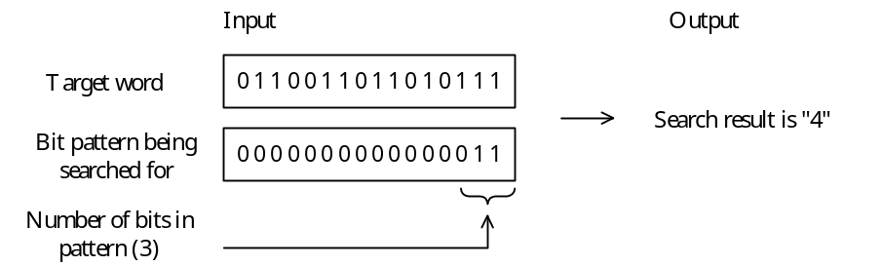
Fig. 1 Relationship between Input and Output

(1) MAIN stores the starting address of the parameters in “GR1” and then calls BPSRCH. Fig. 2 shows the contents of the parameters.

(GR1) + 0 | Target word
+ 1 | Bit pattern to be searched for (right justified)
+ 2 | Number of bits in pattern (n) | 1 ≤ n ≤ 16
Fig. 2 Contents of Parameters

(2) BPSRCH stores the search results in “GR0.”
(3) After control returns from BPSRCH, the original contents of the general-purpose registers GR2 and GR3 are restored.

[Program]
(Line Number)
01 MAIN START
02 LEA GR1,PARAM
03 CALL BPSRCH
04 EXIT
05 PARAM DC #CDEF
06 DC #0003
07 DC 2
08 BPSRCH PUSH 0,GR2
09 PUSH 0,GR3
10 LEA GR3,16
11 SUB GR3,2,GR1
12 LD GR2,1,GR1
13 SLL GR2,0,GR3
14 ST GR2,SRCHP ; Stores pattern to be searched for
15 LEA GR2,-1
16 SLL GR2,0,GR3
17 ST GR2,MASKP ; Stores the mask pattern
18 LEA GR3,0
19 LEA GR0,0
20 LD GR2,0,GR1 ; Searches for the pattern
21 LOOP ADD GR3,2,GR1
22 CPA GR3,MAXP
23 JPZ RESULT
24 PUSH 0,GR2
25 AND GR2,MASKP
26 CPL GR2,SRCHP ; Compares the pattern
27 JNZ NEXT
28 ADD GR0,ONE
29 POP GR2
30 PUSH 0,GR3
31 LD GR3,2,GR1
32 SLL GR2,0,GR3
33 POP GR3
34 JMP LOOP
35 NEXT SUB GR3,2,GR1
36 LEA GR3,1,GR3
37 POP GR2
38 SLL GR2,1
39 JMP LOOP
40 RESULT POP GR3
41 POP GR2
42 RET
43 ONE DC 1
44 MASKP DS 1
45 SRCHP DS 1
46 MAXP DC 17
47 END

Sub-Question 1
Select the correct answers to insert in the corresponding boxes () in the following description from the choices provided below. You may select any answer more than once.

When line 3 of the program is executed and control has returned to the main program, the value of “GR0” is , the value of MASKP is , and the value of SRCHP is .

Answer group for a:
a) 3 b) 4 c) 5 d) 6 e) 7 f) 8

Answer group for b and c:
a) #1000 b) #3FFF c) #4000
d) #5FFF e) #6000 f) #A000
g) #B000 h) #C000

Sub-Question 2
An instruction in Subprogram BPSRCH becomes unnecessary if the “bit pattern to be searched” in the parameter shown in Fig. 2 is changed to left-justified. Choose the number of the line which becomes unnecessary.

Answer group:
a) 11 b) 13 c) 16 d) 22 e) 26

Sub-Question 3
Assume that lines 29 through 39 of BPSRCH are changed as shown below, and then the main program MAIN is executed. What will be the value of “GR0” when line 3 of the program is executed and control has returned to the main program?

NEXT POP GR2
SUB GR3,2,GR1
LEA GR3,1,GR3
SLL GR2,1
JMP LOOP

Answer group:
a) 3 b) 4 c) 5 d) 6
e) 7 f) 8 g) 9 h) 10

